**2. Overall Description**

* 1. **Product perspective**

As a result, an entirely new mobile app will be developed that uses Yandex maps as additional service. Tracking the user's location will be performed with the help using the built-in sensors of the mobile device. Yandex Map API is responsible for displaying available stores and building the path to them.

The detailed architecture of the program and its interaction with third-party API will be described below.

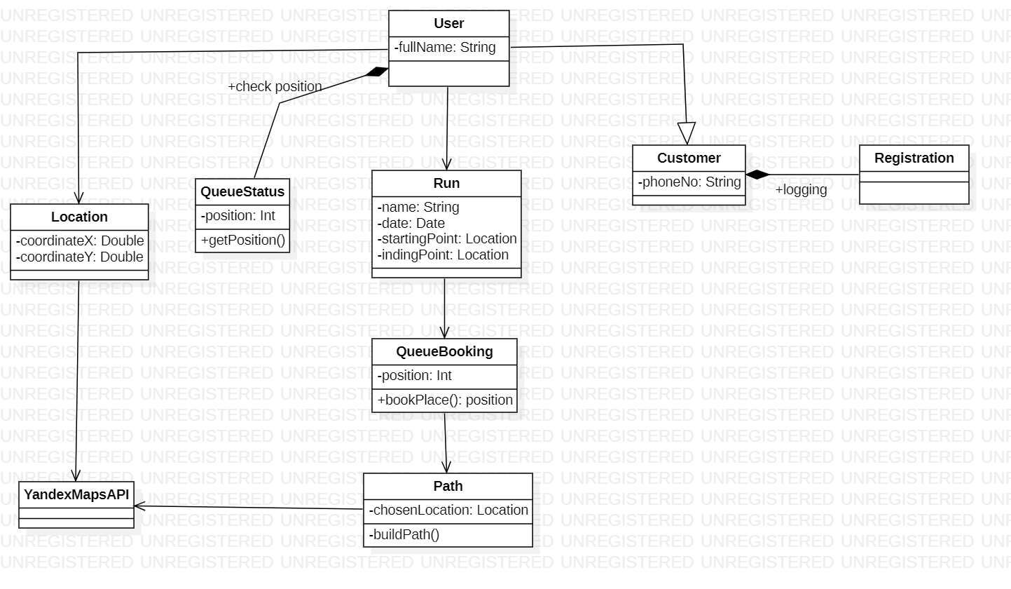

demo

**2.4 Domain Assumptions**

[D1] - Registration is via the phone number.

[D2] - The device must have stable access to the Internet to establish a user status and queue calculation.

[D3] - The user goes to the selected shop according to the notification on the mobile device.

[D4] - The user should follow the rules that will be notified on the device (i.e. social distance, the presence of a mask, allocated time for purchase).

[D5] - The user goes to the selected shop according to the notification on the mobile device.

[D6] - People who cannot use the device should easily integrate into the queue by registering on the spot.

[D7] - The store will be entered using a QR code.

[D8] - Store owners will have access to an expanded version of the app for more control and tracking of the flow of customers.